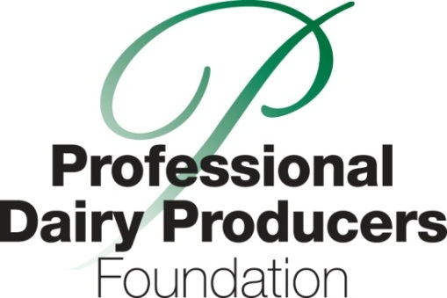

June 23, 2015
Contact Deb Reinhart
800-947-7379
dreinhart@dairyfoundation.org.

Professional Dairy Producers Foundation awards grants
for education projects in 2015
Juneau, Wis.—The Professional Dairy Producers Foundation (PDPF) board of directors has made its funding decisions for education projects for dairy producers and their communities. The Foundation is proud to award the following grants:
- The Northern Indiana Dairy Trail involves open houses at 12 dairy farms in six northern Indiana counties during June and October of 2016. The dairy trail features educational events that give local farmers the stage to tell the dairy story. This event is part of a larger initiative to celebrate Indiana’s bicentennial in 2016. By creating opportunities for local farmers to communicate directly with consumers, the dairy industry inspires trust in it production practices.
- The Yahara Pride Farms certification program is a non-regulatory program designed to help farmers of the Yahara watershed to identify the strength and weaknesses of their farming systems and nutrient management. This voluntary, farmer-led program encourages the use of effective nutrient management and conservation practices that reduce phosphorus in our waterways, and improve soil and water quality in the Yahara watershed.
- The Food Armor™ WVMA HACP for Proper Drug use, is a proven six-section on-farm program with the goals of food safety and responsible use of animal medications. It is tailored to each dairy farm and is designed to empower the farm veterinarian and the farm personnel as they work together. Food Armor™ is part of a larger initiative and partnership between WVMA and PDPW called “WHAT MATTERS - veterinarians and producers working together to ensure safe meat and milk.”
- The Assisting Farmer Leadership in Watershed Education and Information Program (WiCAER) is designed to help farmers better understand the goals and objectives of regional watershed programs. This farm-led initiative provides education and training to farmers to better understand how agriculture impacts water quality and document adoption practices that protect and enhance water quality. The WiCAER program will serve as a bridge between farmers and the public to provide understanding of what agriculture is doing to protect water quality.
The Professional Dairy Producers Foundation awards grants to non-profit organizations who share the Foundation’s passion and vision for education in dairy communities. Grant dollars are available to those organizations with unique ideas in the following two focus areas: 1) Building producer professionalism, or 2) Maintaining public trust.
The next granting period begins now, with grant applications due December 1, 2015. Organizations may apply for grants of up to $5,000. The maximum amount given to any one organization will be $5,000. For grant criteria and an application package, visit www.dairyfoundation.org.
The Professional Dairy Producers Foundation is a producer-led 501(c)(3) charitable organization that raises funds for educational programs throughout the United States. The Foundation supports programs that develop the skills of our dairy producers and youth and maintain public trust. For more information on programs funded and ways to donate, visit www.dairyfoundation.org.
###

